**Support/Service**

1

RefMech remains the leading manufacturer  of refractory anchores and has developed the most complete inventory of stock  stainless steel anchores and fixings

.*Refractory anchor for Ceramic Fibre blanket Lining

*Refractory anchor for Ceramic fibre Module/Block lining

.* Refractory anchor for  Brick lining

*Refractory anchors for Castable lining

*Refractory anchors for element holding

* Refractory anchor in V,Y,U,corbal, Spiral types

*Customised refractory anchors

By interacting and observing the practical experience of  refractory applications  and reacting to their customers need RefMech makes it more convenient for you to consider them for all your refractory/ceramic fibre anchors requirments.

RefMech are Delhi based and have standard anchors available for immediate despatch.Large stock of SS 304, SS310  sheet, plate, rod ,wire coil enable us to respond to customers immediate requirments .

Refmech Engineering gives you right-from-the-source maintenance expertise. From Gate Operators to Telephone Entry Systems, we can ensure your equipment is running at maximum efficiency.

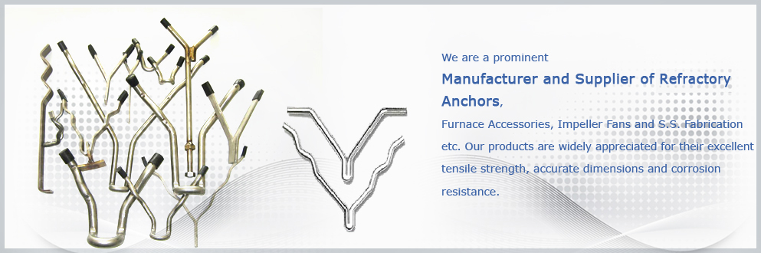

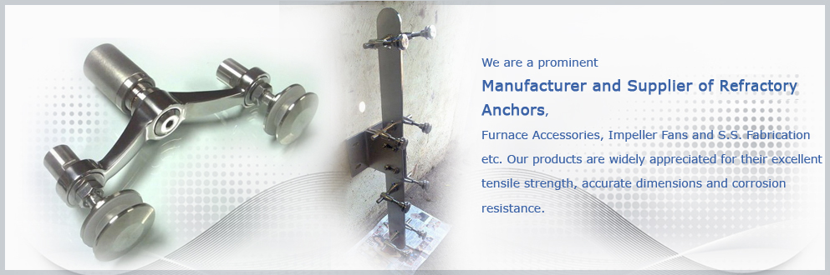

# COMPANY PROFILE

**RefMech Engineering** **remain the leading manufacturer and exporter of high quality refractory anchors in stainless steel ,nickel alloy material and has developed the most complete inventory of stock stainless steel refractory anchors and fixings.The anchors are used to hold refractory lining in Furnaces,kilns,Reformers,Incinerators,Boilers and other high temperature Equipments.**

**RefMech manufacturing range includes Stainless steel Stud & nut,SS flanges, SS Fabrication, SS stud and twist washer (Blanket lining) SS channel anchor (Ceramicic fibre Modular/Block lining) , refractory anchors in stainless steel or other alloys type V, type Y, type Corbel, type Spiral, type corrugated, customized anchors,SS fittings and allied components of burner, oil pump etc for furnaces .**

**Refmech serve to the best satisfaction of their clients in India and abroad. The industries we serve are:**

**Cement, Steel, Refinery, Fertilizers , Petrochemical, Ceramic, Heat treatment Furnace, Process Industries,Food Industries , Pharmaceuticl Industries, Powerhouses,ceramic industries ,glass industries auto industries.**

**Quality is the prime objective of RefMech that plays a vital role to keep our clients satisfied and long term business relations**

**RefMech manufacture and deliver the quality products by adopting standardized norms of production quality control at their works under the supervision and control of highly experienced engineers. The raw material is purchased from reputed and reliable sources and testing abefore processing for production.**

**Us**  
RefMech meet the variegated requirements of the diverse clients, we have well-developed infrastructure at Delhi/Noida. This infrastructure is :

International quality standard range  
Well equipped manufacturing facility  
Expert team of engineers, industrial designers and other supporting staff  
Customized and highly qualified team of professionals, which is well-versed with the intricacies of this domain and provide the personalized services

Applications :  
  
• Steel Industries.  
• Cement Industries.  
• Heat Tretment Plants.  
• Process Industries.  
• Thermal Plants.  
  
• Petro Chemical Industries.  
• Fertilizers Industries  
• Power Generation Industries  
• Boilers  
• Pharmaceutical Industries

Why Us ?

The key factors for which we have received appreciation from our clients all across the globe include:

International quality standard range  
Well equipped manufacturing facility  
Expert team of engineers, industrial designers and other supporting staff  
Customized packaging  
Competitive prices

Our Team

Backed by our efficient and highly experienced team of professionals, we have been able to offer a wide range of stainless steel nuts & bolts, furnace accessories, impeller fans, refractory furnace washers, anchors, washer stud, nut bolts, impeller fans, thermo couples, AISI 304/310, inconle, ceramic cup-locks and S. S. fabrication, etc. To our esteemed clients. Our team of professionals manufactures these products from high-grade raw material procured from the trusted vendor of the market. Further, our team of quality controllers stringently tests the products on various parameters before and after procurement to offer a flawless range of products. The professionals of our firm are employed on the basis of their experience and vast knowledge in their respective domains.

Our Infrastructure

We have a well-developed infrastructure which is spread over an extensive area. Equipped with latest technology machineries, equipment and tools, we are able to cater the emerging demands of the customers. Further, we have segregated our manufacturing unit into separate division to ensure the production of flawless range of products. In addition to this, we make sure that the machineries and the equipment used by us are timely serviced and upgraded to serve quality assured range of products to the customers. Being a successful business entity in domestic market, we have emerged ourselves as a leading firm in international market as well.

* [**HOME**](http://pawaskarenggworks.com/index.html)
* [**REFRACTORY ANCHORS**](http://pawaskarenggworks.com/refractory_support_anchors.html)
* [**CERAMIC FIBER LINING**](http://pawaskarenggworks.com/fiberlininganchor.html)
* [**IMPELLER FANS**](http://pawaskarenggworks.com/impellerfan.html)
* [**CASTABLE PAN MIXER**](http://pawaskarenggworks.com/mixingmachine.html)
* [**BRICK CUTTING MACHINE**](http://pawaskarenggworks.com/castablecuttingmachine.html)

# PAWASKAR MANUFACTURES OF

* http://pawaskarenggworks.com/images/bulet.jpg[Refractory Anchors for Castable](http://pawaskarenggworks.com/castableanchor.html)
* http://pawaskarenggworks.com/images/bulet.jpg[Refractory Retainer Plates](http://pawaskarenggworks.com/refractory_support_anchors.html)
* http://pawaskarenggworks.com/images/bulet.jpg[RefractoryStud And Washer](http://pawaskarenggworks.com/twistrefractorystuds.html)
* http://pawaskarenggworks.com/images/bulet.jpg[Refractory Anchors for Element Holding](http://pawaskarenggworks.com/elementholding.html)
* http://pawaskarenggworks.com/images/bulet.jpg[Refractory For Studs And Nut](http://pawaskarenggworks.com/anchorsstudsandnut.html)
* http://pawaskarenggworks.com/images/bulet.jpg[Washers for Refractory Anchors](http://pawaskarenggworks.com/washersanchors.html)
* http://pawaskarenggworks.com/images/bulet.jpg[Refractory Ceramic Stud With Lock Anchor](http://pawaskarenggworks.com/anchorsforceramic.html)
* http://pawaskarenggworks.com/images/bulet.jpg[Refractory 'Y' Anchors & Crook Anchors](http://pawaskarenggworks.com/yanchor.html)
* http://pawaskarenggworks.com/images/bulet.jpg[Refractory Anchors for Special Lock Washers](http://pawaskarenggworks.com/speciallockwasher.html)
* http://pawaskarenggworks.com/images/bulet.jpg[Refractory Spiral 'Y' Type Anchors](http://pawaskarenggworks.com/spiralytypeanchor.html)
* http://pawaskarenggworks.com/images/bulet.jpg[Customised Refractory Anchors](http://pawaskarenggworks.com/customisedanchor.html)
* http://pawaskarenggworks.com/images/bulet.jpg[Refractory 'U' Base 'V' Anchors](http://pawaskarenggworks.com/ubasevanchor.html)
* http://pawaskarenggworks.com/images/bulet.jpg[Refractory Anchors For Ceramic Fibre Lining](http://pawaskarenggworks.com/anchorforceramic.html)
* http://pawaskarenggworks.com/images/bulet.jpg[Dual Layer Split Refractory Anchors](http://pawaskarenggworks.com/splitrefractoryanchors.html)
* http://pawaskarenggworks.com/images/bulet.jpg[Refractory Y Anchors Corrugated](http://pawaskarenggworks.com/yanchorscorrugated.html)
* http://pawaskarenggworks.com/images/bulet.jpg[Refractory V Type Anchors](http://pawaskarenggworks.com/vtypeanchor.html)
* [](http://pawaskarenggworks.com/contact.html)
* [HOME](http://pawaskarenggworks.com/index.html)
* [ABOUT US](http://pawaskarenggworks.com/about_us.html)
* [PRODUCTS](http://pawaskarenggworks.com/products.html)
* [SITEMAP](http://pawaskarenggworks.com/sitemap.html)

